Subtract The Product and Sum of Digits
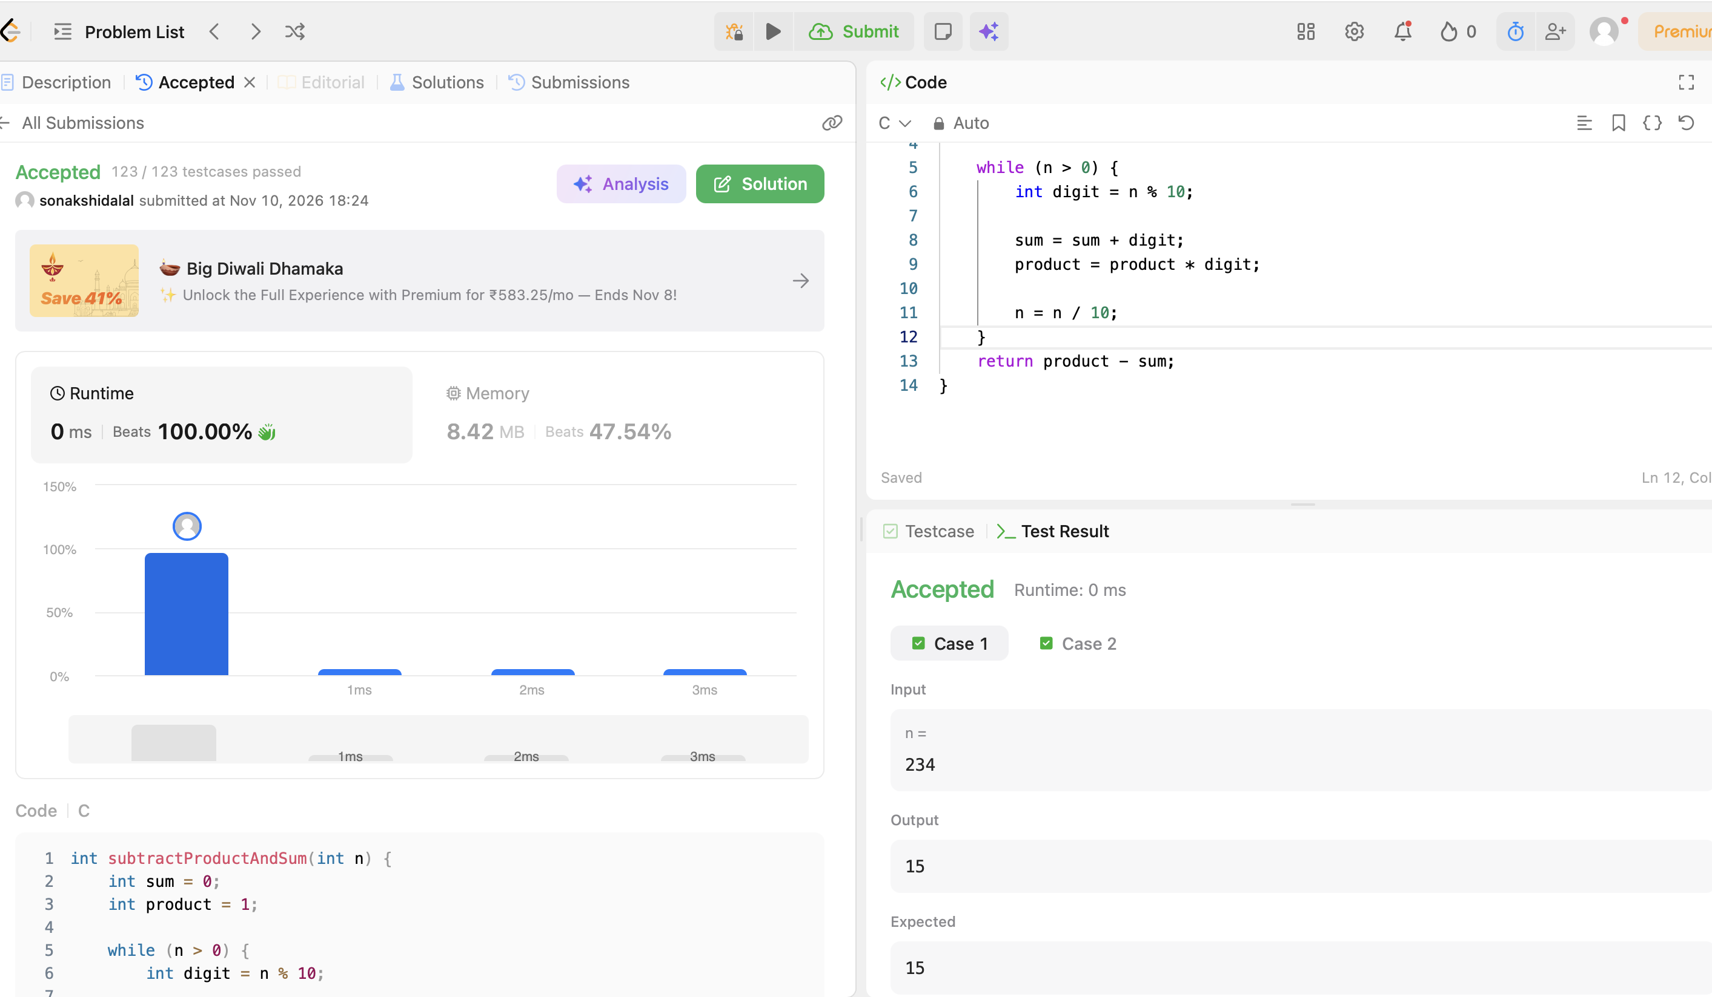
CODE:
int subtractProductAndSum(int n) {
int sum = 0;
int product = 1;

while (n > 0) {
int digit = n % 10;

sum = sum + digit;
product = product * digit;

n = n / 10;
}
return product - sum;
}

